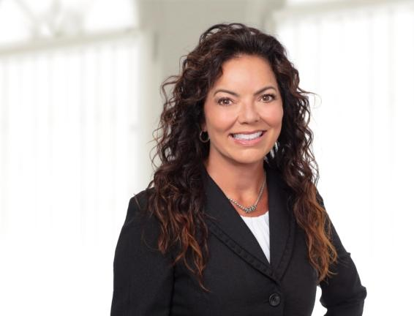 | PARTNER  TONYA J. BOND  T. 317-637-0700 x236  E. tbond@psrb.com  Office: Indianapolis

Practices  Business  Insurance Coverage  Litigation  Industries  Agribusiness  Education & Schools  Manufacturing  Municipalities & Government  Nonprofit & Religious Organizations  Petroleum Marketers  Waste Services | Overview  Tonya J. Bond advises and represents businesses, individuals, local governments, and nonprofit organizations. She litigates a wide variety of complex matters for both plaintiffs and defendants including commercial transactions, insurance recovery for policyholders, wrongful death, and premises and products liability cases. In addition to litigation, Tonya practices appellate work at both the state and federal levels. She also serves as General Counsel for the Indiana Sheriffs’ Association and Legal Deputy for several Sheriffs’ Offices.  Tonya is actively involved in the legal community, serving the Indiana State Bar Association, the Indiana Judges and Lawyers Assistance Program (JLAP) Committee, and the Indiana Conference for Legal Education Opportunity (Indiana CLEO) Advisory Committee. She also serves as an Adjunct Faculty Member at IUPUI Kelley School of Business where she teaches Business Law.  Awards  - 2014-2024 – Selected for inclusion in Indiana Super Lawyers – Business Litigation  - 2018-2019 Top 25 Women  - 2013-2024 – Selected for inclusion in Best Lawyers in America®  - 2022 – Insurance Law – Litigation Lawyer of the Year in Indianapolis  - 2014-present – Martindale-Hubble AV® Preeminent TM Peer Review Rated  - 2022 – Fellow, Litigation Counsel of America, The Trial Lawyer Honorary Society  - 2010-2013 – Selected for Inclusion in Indiana Super Lawyers – Rising Star – Insurance Coverage  - 2012 – Indiana State Bar Association Leadership Development Academy Graduate  - 2009 – Indiana Lawyer’s Up and Coming Lawyer Award  Education  - J.D., 2004, Indiana University Indianapolis, Robert H. McKinney School of Law  - B.A., 2000, Indiana University, Indianapolis  Bar Admissions  - State of Indiana, 2004  - United States District Court for the Southern District of Indiana, 2004  - United States District Court for the Northern District of Indiana, 2004  - United States Court of Appeals for the Second Circuit, 2011  - United States Court of Appeals for the District of Columbia Circuit, 2016  - United States Court of Appeals for the Seventh Circuit, 2022  Affiliations  Professional Affiliations  - Indiana State Bar Association  - Executive Board Treasurer (2023)  - Leadership Development Academy  - Chair (2019-2022)  - Vice Chair (2016-2018)  - Committee Member (2012-Current)  - Graduate (Class 1, 2012)  - Board of Governors (2013-2015)  - Professional Legal Education, Admission & Development (PLEADS) Council  - Chair (2015-2016)  - Secretary (2014-2015)  - 2007 Annual Meeting Planning Committee  - Member (2004-Current)  - Judges and Lawyers Assistance Program (JLAP)  - Committee Member (2016-Current)  - Committee Member (2004-2012)  - Volunteer (2003-Current)  - American Inn of Court  - Barrister  - Indianapolis Bar Association  - Member (2004-Current)  - Indianapolis Legal Aid Society  - Member  - Marion County Bar Association  - Member (2020-Current)  - Litigation Counsel of America (LCA)  - Trial Law Institute  - Member  - Diversity Law Institute  - Member  Community Affiliations  - Indiana University, Robert H. McKinney School of Law  - Chair, Alumni and Student Engagement Committee  - Board Member  - Lawrence Township School Council Legislative Committee  - Co-Chair (2009)  - Child Advocates (2006-2007)  - Board Member (2006-2007)  - Volunteer (2000-2007)  Articles & Events  2022 | Speaking Engagement  Speaker, “Top Ten Lessons in Leadership Learned Over the Past Ten Years” Indiana State Bar Associations Paralegal Symposium  2011 | Publication  Contributing Author to Insurance Coverage Chapter, The Meth Solution: How to Eliminate Meth Residue in Homes, Donetta J. Held, How to Publishers (2011)  2009 | Speaking Engagement  Speaker “Insurance Coverage: It Pays When You Get It, But Can Cost You When You Don’t,” Indianapolis Bar Association  2007 | Publication  Author and Speaker, “Bad Faith Insurance Claims in Indiana,” National Business Institute  2003 | Publication  Author, International Criminal Court: Better than Nuremburg?, note, 14 Ind. Int’l & Comp. L. Rev. (2003)  Many speaking engagements on behalf of JLAP

