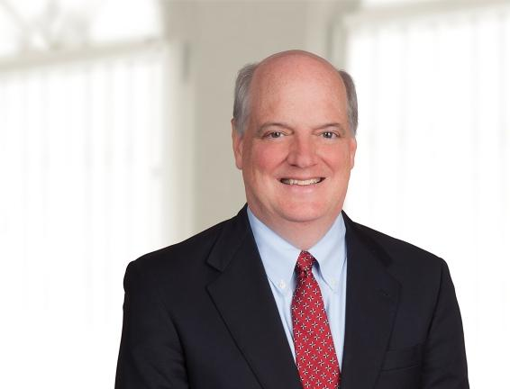 | PARTNER  JOHN D. MORIARTY  T. 317-637-0700 x232  E. jmoriarty@psrb.com  Office: Indianapolis

Practices  Environmental  Insurance Coverage  Litigation  Industries  Agribusiness  Energy & Utilities  Individuals & Closely Held Businesses  Manufacturing  Municipalities & Government  Petroleum Marketers  Real Estate Development & Construction  Waste Services | Overview  John Moriarty represents policyholders in insurance coverage matters and plaintiffs and defendants in environmental and other litigation matters. His insurance coverage work includes multiple matters concerning cleanups arising from gasoline stations and dry cleaning operations. John is particularly well versed in the Indiana Department of Environmental Management’s (IDEM) Underground Storage Tank Program’s rules, laws and policies. John has successfully prosecuted administrative appeals with Indiana’s excess liability trust fund to clean up contaminated petroleum sites. John defends property owners against claims involving Indiana’s Environmental Legal Action Statute and Underground Storage Tank Act.  In addition, John represents buyers and sellers of gas stations, dry cleaners, and contaminated properties in numerous real estate transactions. John defends towns and cities against environmental claims asserted by IDEM and the US EPA.  John’s numerous bar association contributions include serving as Chair (2007-2008), Newsletter Editor (2003-2006) and Treasurer and Chair-Elect (2005-2007) of the Environmental Law Section of the Indiana State Bar Association.  Education  - J.D., 1995, Indiana University Indianapolis – Robert H. McKinney School of Law  - M.B.A., 1991, University of Notre Dame  - B.S., 1989, Business Administration, Indiana University – Bloomington  Bar Admissions  - State of Indiana, 1996  - Northern District of Indiana, 1996  - Southern District of Indiana, 1996  Experience  - US EPA CERCLA Administrative Settlement Agreement and Order On Consent For Removal Action For Vernon L. Graves Revocable Living Trust, Docket No. V-W-15-C-021 (2015)  - Titan Industries v. George F. Cram Co., (Marion County Superior Court, March 25, 2013), Cause No. 49F12-1002-PL-007087  - Darrell Blasius v. Indiana Insurance Company, (Marion County Superior Court, June 26, 2014), Cause No. 49F-1110-PL-040523  - Michael Schmidt v. Allstate Insurance Company, (Marion County Superior Court, June 19, 2013), Cause No. 49D12-1111-PL-04275  - Indiana Department of Environmental Management v. Rowe Brothers, Inc., (Marion County Superior Court, January 20, 2009)  - Richard U. Pflanz v. Merrill Foster, 888 N.E.2d 756 (Ind. 2008)  - State Farm Fire & Casualty Co. v. Anthony J. Cefali Trust, Cause No. 45D04-0507-PL-00030 (Lake County Superior Court, January 25, 2007), 2007 WL 1152987  - American Home Assurance Co. v. Thomas G. Allen, et al., 814 N.E.2d 662 (Ind. Ct. App. 2004)  - Indiana Department of Environmental Management v. Adapto, Inc., 717 N.E.2d 646 (Ind. Ct. App. 1999)  - Deputy Prosecuting Attorney, Miami County, Indiana 1997 to 1998  Affiliations  Professional Affiliations  - Member, Indiana State Bar Association, Environmental Law Section (Chair 2007-2008, Vice Chair 2006-2007, Treasurer 2005-2006, Newsletter Editor 2003-2006)  - Member, Indianapolis Bar Association, Environmental Law Section and Insurance Coverage Section  - Member, American Bar Association  - Member, Notre Dame Alumni Club of Indianapolis  - Law Firm Campaign Chair, Indiana University School of Law- Indianapolis (2003- present)  Community Affiliations  - Board Member, Keep Indianapolis Beautiful, Inc., 2016 – present  - Committeeperson of the Year, Keep Indianapolis Beautiful, Inc. 2015  - Board Member, St. Thomas More Society

