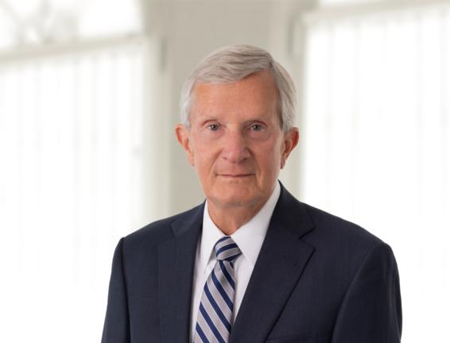 | SENIOR COUNSEL  JAMES BURNS  T. 317-637-0700 x117  E. jburns@psrb.com  Office: Indianapolis

Practices  Litigation  Industries  Health Care & Life Sciences  Individuals & Closely Held Businesses | Overview  James Burns is Senior Counsel with the Litigation Group of Plews Shadley Racher and Braun. He represents clients in a wide range of litigation matters, especially those related to pharmaceutical and medical device products. He also assists clients with matters of corporate compliance and risk management. Jim retired as Assistant General Counsel of Eli Lilly and Company after nearly 28 years of service. While there, he managed all company litigation on matters including products liability, intellectual property, antitrust, human resources and general commercial litigation. During his career at Lilly, he also served as General Counsel to Elizabeth Arden Inc. in New York City and Elanco Products Company in Indianapolis.  He has been active in the area of tort reform and served on the Board of Directors of the American Tort Reform Association and Product Liability Advisory Council. He also played an active role in the formulation of the Restatement of Law-Third relating to pharmaceutical products.  Jim received a Bachelor of Arts in political science from Indiana University. He earned his Juris Doctor Magna Cum Lauda from Indiana University McKinney School of Law where he served for many years as a member of the Board of Visitors.  He is admitted to practice in all Indiana state courts and in the U.S. District Court for the Southern District of Indiana.  Awards  - 2013-2023, Listed in Best Lawyers in America®  - Indiana University President’s Circle Award  - McKinney School of Law Distinguished Alumni Award  - IUPUI Spirit of Philanthropy Award  Education  - 1972, B.A., Education, Indiana University, Bloomington  - 1975, J.D., magna cum laude, Indiana University McKinney School of Law, Indianapolis  Bar Admissions  - State of Indiana  - U.S. District Court for the Southern District of Indiana  Affiliations  Community Affiliations  - United Way Tocqueville Society

