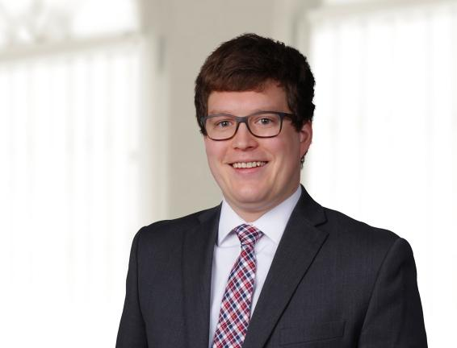 | ASSOCIATE  CHRISTOPHER E. KOZAK  T. 317-637-0700 x211  E. ckozak@psrb.com  Office: Indianapolis

Practices  Business  Environmental  Insurance Coverage  Litigation  Industries  Energy & Utilities  Health Care & Life Sciences  Manufacturing  Municipalities & Government  Real Estate Development & Construction | Overview  Chris is a top-flight insurance-coverage and appellate litigator. He has written briefs in over 20 appellate matters and has experience with CGL, D&O, EPL, Professional Liability, Homeowner’s, Commercial Property, Business Income, Excess/Umbrella, and life insurance coverage. He is known for his ability to penetrate complex issues, identify and wrangle the relevant details, and present them to courts with clarity and wit. He uses those skills to his clients’ advantage when disputes go to court, where providing a clear argument in a complicated case can be the difference between winning and losing. Chris’s clients range from individual policyholders to multi-national companies, and he has assisted clients in disputes ranging from $1,200 to those involving hundreds of millions of dollars.  Chris is a summa cum laude graduate of the Michigan State University College of Law and comes to PSRB with experience in a broad range of legal subjects, including federal jurisdiction, civil procedure, e-discovery, administrative law, and evidence. He has also done extensive immigration work with the University of Michigan Law School’s Human Trafficking Clinic. As a member and Editor of the law review, he has reviewed hundreds of articles on current legal subjects and determined which ones would contribute best to the development of the law. And while clerking for Judge David McKeague on the U.S. Court of Appeals for the Sixth Circuit, he advised the Judge on 25% of the appeals assigned to the chambers, requiring him to learn about virtually every kind of law that surfaces in federal court. This broad knowledge base allows Chris to think about client problems creatively and pursue innovative legal strategies.  When he has time, Chris enjoys doing pro bono work, and is particularly interested in civil rights issues and in assisting survivors of human trafficking.  Education  - J.D., summa cum laude, 2017, Michigan State University College of Law  - B.A., summa cum laude, 2014, Legal Studies, Ball State University  Bar Admissions  - U.S Supreme Court, 2021  - U.S. Court of Appeals for the Ninth Circuit, 2021  - U.S. Court of Appeals for the Tenth Circuit, 2019  - U.S. Court of Appeals for the Seventh Circuit, 2019  - State of Indiana, 2019  - State of Michigan, 2017  - U.S. Court of Appeals, Sixth Circuit, 2018  - U.S. District Court, Western District of Michigan, 2018  - U.S. District Court, Eastern District of Michigan, 2018  - U.S. District Court, Northern District of Indiana, 2018  - U.S. District Court, Southern District of Indiana, 2018  Experience  - Counsel for Appellee, USA Gymnastics v. Liberty Ins. Underwriters, Inc., 46 F. 4th 571 (7th Cir. 2022)  - Counsel for Appellee, USA Gymnastics v. Liberty Ins. Underwriters, 46 F.4th 499 (7th Cir. 2022)  - Counsel of Record for Amicus Curiae, Mallory v. Norfolk S. Ry. Co., No. 21-1168 (U.S., Heard Nov. 4, 2022).  - Counsel for Appellant, Ind. Repertory Theatre v. Cincinnati Ins. Co., No. 21A-CP-2848 (Ind. Ct. App.) (Heard Jan. 17, 2023)  - Counsel for Amicus Curiae, Stant USA Corp. v. Factory Mut. Ins. Co., 22-1336 (7th Cir.) (Heard Nov. 1, 2022)  - Counsel for Amicus Curiae, First & Stewart Hotel Owner, LLC v. Fireman’s Fund Ins. Co., No. 21-35637 (9th Cir.)  - Counsel for Appellant, Ind. Repertory Theatre v. Cincinnati Ins. Co., No. 21A-PL-628 (Ind. Ct. App. 2022)  - Counsel for Amicus Curiae Purdue University, Circle Block Partners, LLC v. Fireman’s Fund Ins. Co., No. 21-2459 (7th Cir. 2022)  - Counsel of Record for Amicus Curiae, Wild Eggs Holdings, Inc. v. State Auto Prop. & Cas. Co., 48 F.4th 645 (6th Cir. 2022)  - Counsel of Record for Amicus Curiae, Mikmar, Inc. v. Westfield Ins. Co., No. 21-3230 (6th Cir. 2022)  - Counsel of Record for Respondents, State ex rel. Zurich Am. Ins. Co. v. Tom James Co., et al., No. 21S-OR-482 (Ind. 2021).  - Counsel of Record for Amicus Curiae, Kirsch v. Aspen Am. Ins. Co., No. 21-1038 (6th Cir. 2021)  - Counsel of Record for Amicus Curiae, Santo’s Italian Café v. Acuity Ins. Co., No. 21-3068 (6th Cir. 2021)  - Counsel of Record for Amicus Curiae, Dakota Girls, LLC v. Phila. Indem. Ins. Co., No. 21-3245 (6th Cir. 2021)  - Counsel for Amicus Curiae, TJBC, Inc. v. Cincinnati Ins. Co., No. 21-1203; Sandy Point Dental v. Cincinnati Ins. Co., No. 21-1186; Crescent Plaza Hotel Owner v. Zurich Am. Ins. Co., No. 21-1316 (7th Cir. 2021)  - Counsel of Record for Appellant (Argued), United States v. Stokes, No. 19-5934 (6th Cir. 2020)  - Counsel for Appellant, Clark-Floyd Landfill, LLC v. Gonzalez, No. 19A-CT-2680 (Ind. Ct. App. 2020)  - Counsel for Amicus Curiae Supporting Rehearing, Emmis Communs. Corp. v. Ill. Nat’l Ins. Co., 929 F.3d 411, reh’g granted, 937 F.3d 836 (7th Cir. 2019)  - Co-Counsel for Appellants, In re Syngenta AG MIR 162 Corn Litig., No. 18-3253 (10th Cir. 2019)  Articles & Events  2023 | Author  The Original Thirteenth Amendment: A Rule of Liberty, 53 Cumb. L. Rev. – TBA  2023 | Co-Author  COVID-19 and Business-Income Insurance: The History of “Physical Loss” and What Insurers Intended it to Mean, 57 Tort Trial & Ins. Prac. L.J. 675 (2023)  2022 | Co-Author  Couch’s “Physical Alteration” Fallacy: Its Origins and Consequences, 56 Tort Trial & Ins. Prac. L.J.  2020 | Co-Author  No One Knows What “Physical Loss” Means: All-Risk Insurance and the Coronavirus, 13:4 Mich. J. Ins. & Indem. L. 9 (Oct. 2020)  2019 | Author  Michigan Insurance and Indemnity Law Journal, Who Says I’m a Criminal? Marijuana Cultivation and the Criminal-Act Exclusion  2019 | Co-Author  Law360, 7th Circ. Decision Creates Minefield for Insurance Industry  2018 | Author  Private Habeas 13 Intercultural Hum. Rts. L. Rev. 261 (2018)  2017 | Author  Originalism, Human Trafficking, and the Thirteenth Amendment, 11 S.J. Pol’y & Just. 62 (2017)

