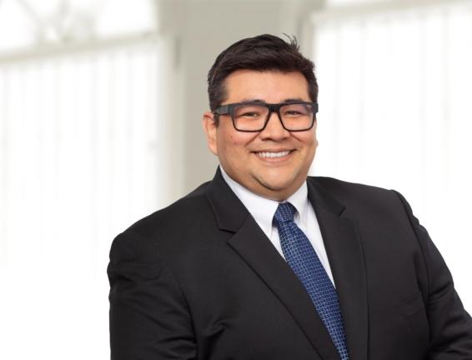 | PARALEGAL  ARTURO DIAZ  T. 317-637-0700 x222  E. adiaz@psrb.com  Office: Indianapolis

Practices  Business  Environmental  Insurance Coverage  Litigation  Real Estate  Industries  Agribusiness  Education & Schools  Energy & Utilities  Individuals & Closely Held Businesses  Manufacturing  Municipalities & Government  Nonprofit & Religious Organizations  Real Estate Development & Construction | Overview  Arturo recently earned a paralegal certificate from Ivy Tech Community College in 2023. As a bilingual legal professional, he is interested in positions that will strengthen his professional experience in Administrative Law and Litigation.  Arturo graduated from the LL.M. program at Robert H. McKinney School of Law in 2018. He is an accomplished Peruvian lawyer graduated from the Pontificia Universidad Católica del Perú (PUCP, 2014), with a strong background in administrative law, public employment law, HR policy in the government, and legal research. In Peru, Arturo conducted comprehensive legal research at the Civil Service Authority (SERVIR) aiming the proposal of the Civil Service Law No. 30057 passed by the Peruvian Congress in 2013. In Indiana, Arturo gained valuable experience as a bailiff in the Marion County Courts Criminal Division.  Education  - 2023, Paralegal Certificate, Ivy Tech Community College, Indianapolis  - 2018, LLM in American Law for Foreign Lawyers, Indiana University, Robert H. McKinney School of Law, Indianapolis  - 2014, Pontificia Universidad Catolica Del Peru School of Law, Lima, Peru  - 2014, Licensed Lawyer in Peru  Affiliations  Professional Affiliations  2018, Hispanic Law Society (HLS) – IU McKinney School of Law  2010, Foro académico Asociación Civil – Pontificia Universidad Católica del Peru  Articles & Events  2010 | Co-Author  Analysis of the Conflict between Israel and the Gaza Strip (Análisis del conflicto entre Israel y la Franja de Gaza), Lima Bar Association Bulletin  2010 | Co-Author  Analysis of the Kosovo case following its declaration of independence in 2008 (Análisis del caso de Kosovo a raíz de su declaración de independencia en el 2008), Lima Bar Association Bulletin

